Definitions:

Low-Density – One Dwelling unit per parcel (includes attached twin homes on separate lots)
Medium Density – 2-4 Dwelling units per parcel (includes attached dwellings/townhomes with 3-4 units on separate lots)
High Density/Multi-Family – 5+ dwelling units per parcel (Includes attached dwellings/townhomes with 5+ units on separate lots)

Future Land Use Categories / Descriptions | Density / Intensity / Design | Photo Illustrations
Downtown Mixed Use
Encompasses a broad range of uses and intensities:  - Governmental offices  - Significant retail  - Arts and entertainment, lodging, conference centers  - Medium density and multi-family housing  - Public and private parking facilities | - Greatest densities and heights  - Protection of historic buildings or building groups  - Design guidelines  - Pedestrian-oriented design  - Limited off-street parking required  - Emphasize river views  - Redevelopment and rehab opportunities | 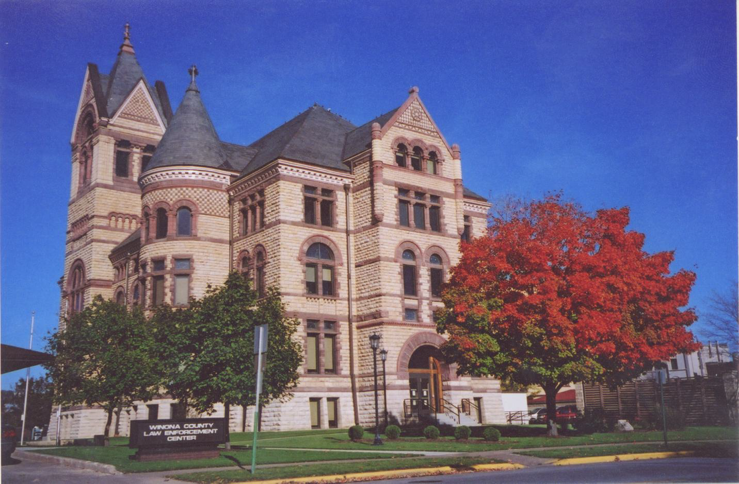 | 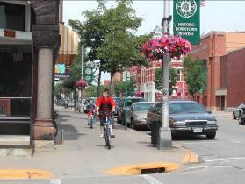
Downtown Fringe
Area supporting the central downtown core, with a similar mix of uses but a lower intensity. Includes ‘arts district,’ medium-high density residential, mixed neighborhood retail and offices, employment centers, public spaces, and satellite parking facilities. | - Medium density and multi-family housing; mixed- use buildings are encouraged  - Pedestrian-oriented design  - Redevelopment opportunities  - Appropriate transitions to adjacent neighborhoods | 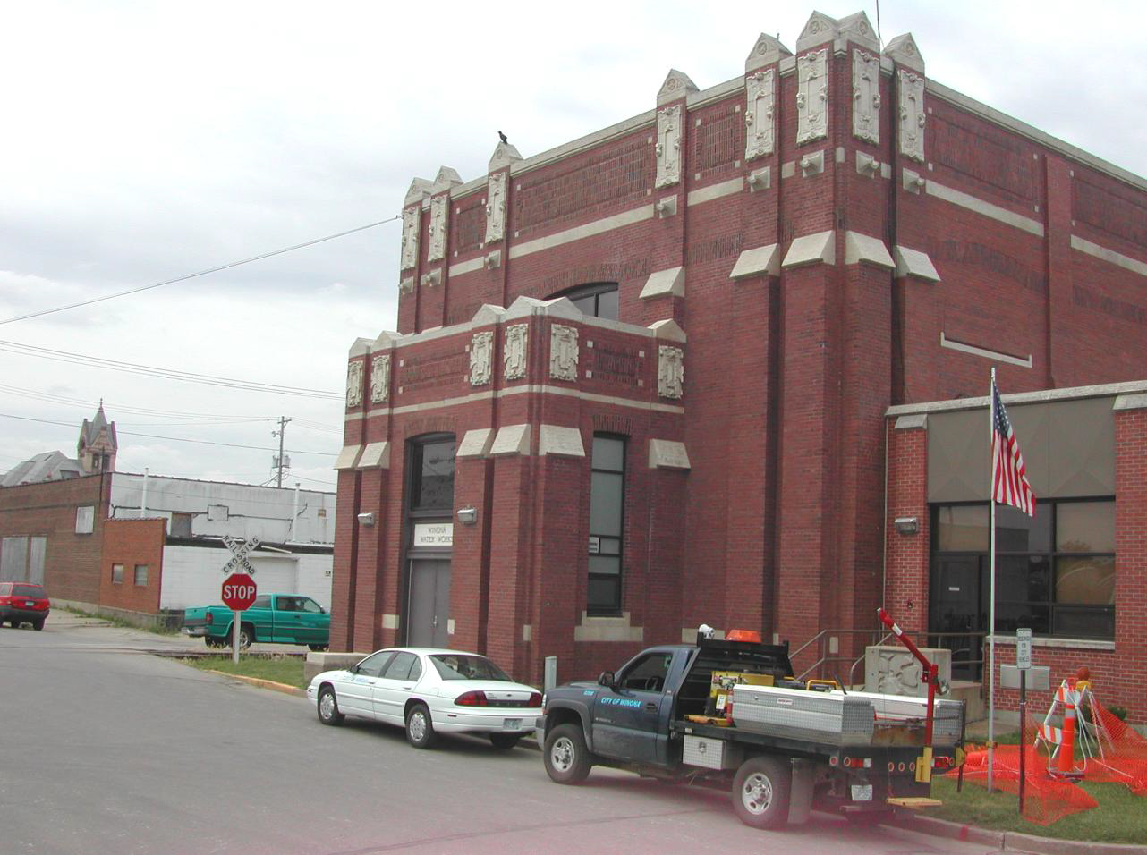 | 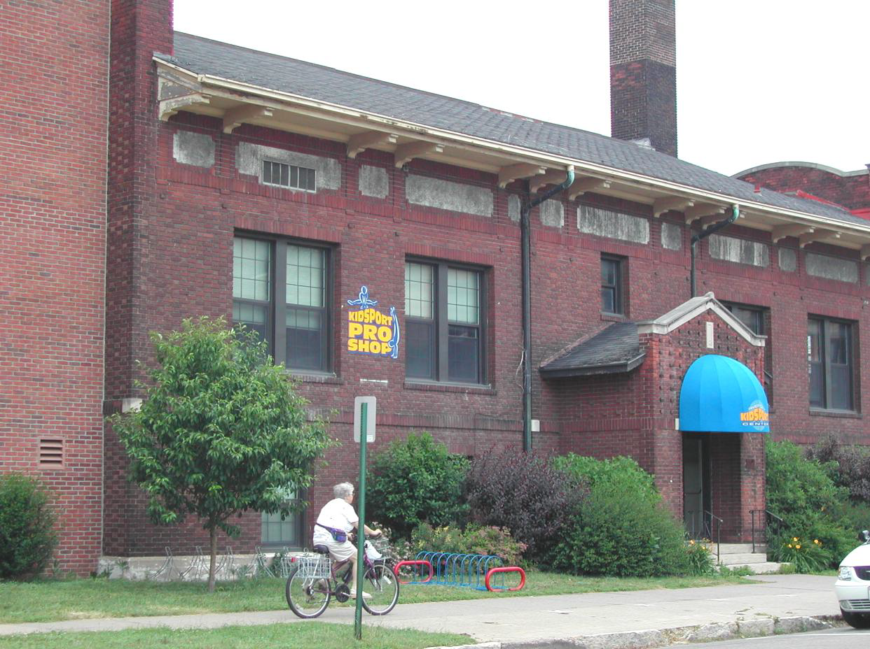
Neighborhood Mixed Use
Small- to moderate scale commercial, serving primarily the adjacent neighborhood(s). May include specialty retail; small businesses such as coffee shops, taverns (existing), offices; studios or housing above retail. May include a variety of housing types interspersed with other uses. | - Medium densities and building heights  - Typically located on historical/standard city lot sizes to encourage fine-grained urbanism, foot traffic, and development consistent with neighborhood scale  - May not be able to meet standard off-street parking requirements – consider some flexibility | 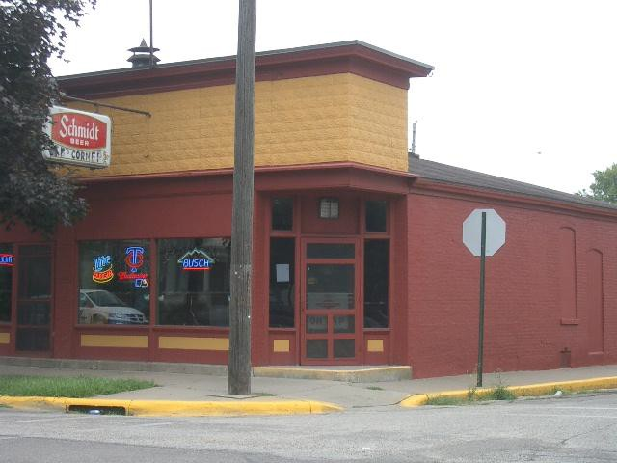 | 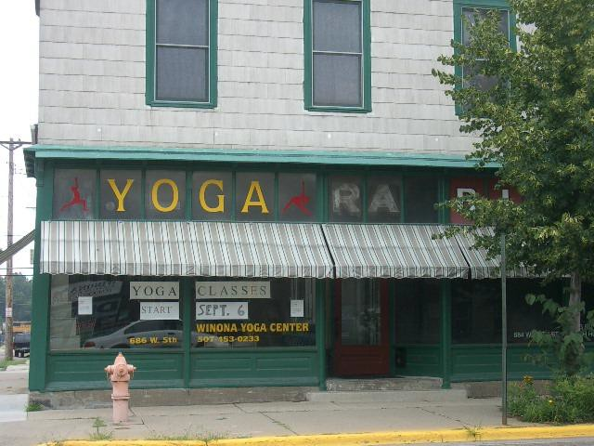

Future Land Use Categories / Descriptions | Density / Intensity / Design | Photo Illustrations
Commercial Mixed Use
Mixed commercial office, Multi-Family residential uses. Also incorporates medium density housing where appropriate – for example as a transition to single-family dwelling areas.To accommodate current auto-oriented growth and situated along arterial roads- typically with parking in front of building and transition to pedestrian orientated commercial mixed use | - Incorporate additional mixed uses to existing sites  - Improve pedestrian circulation and connections to adjacent neighborhoods  - Enhance appearance with landscaping, materials and signage standards | 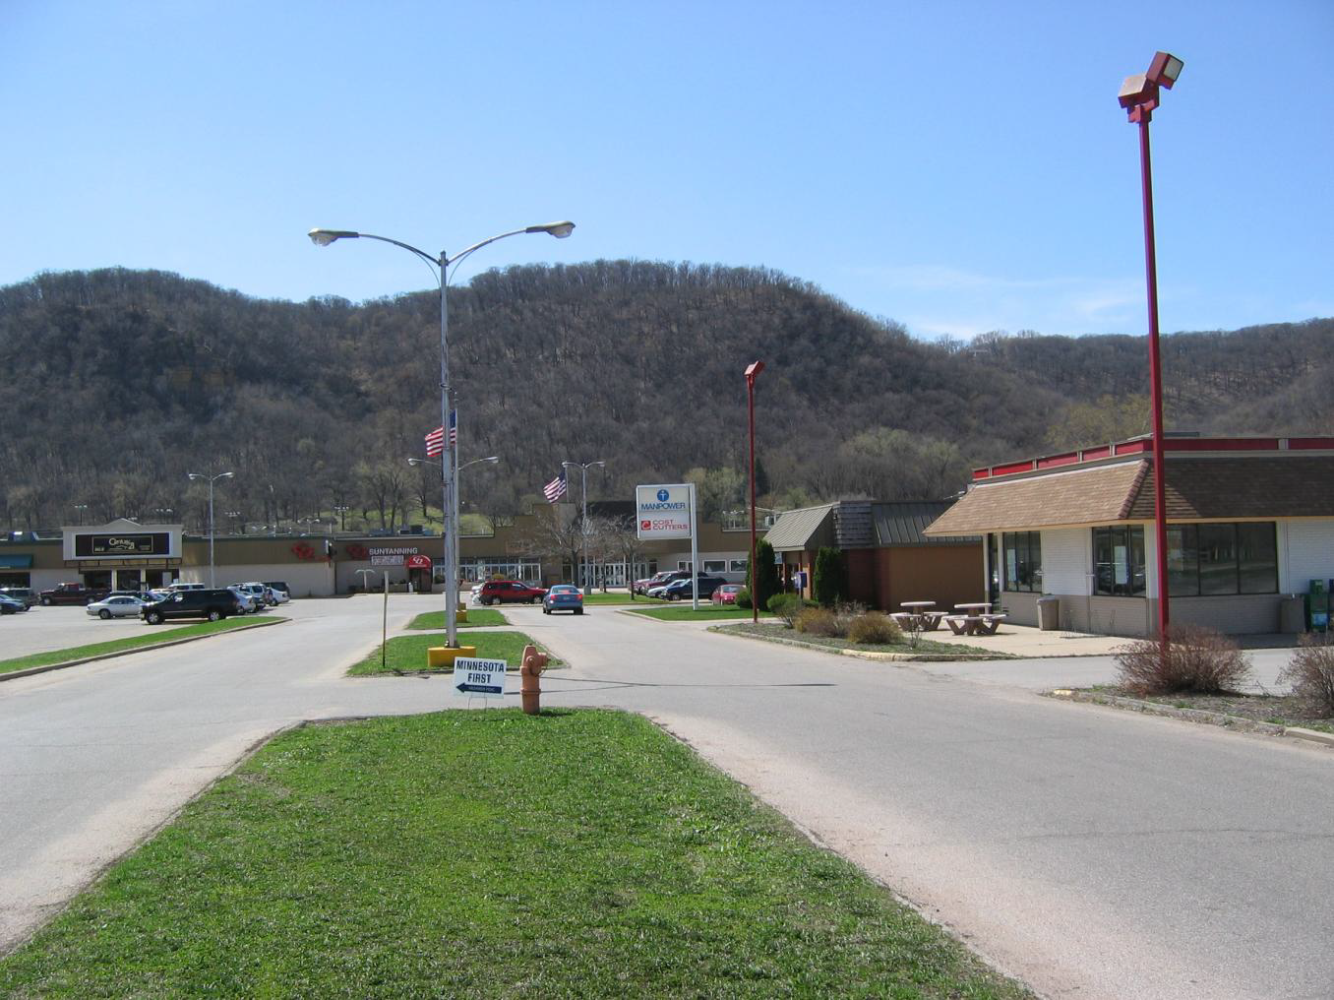 | 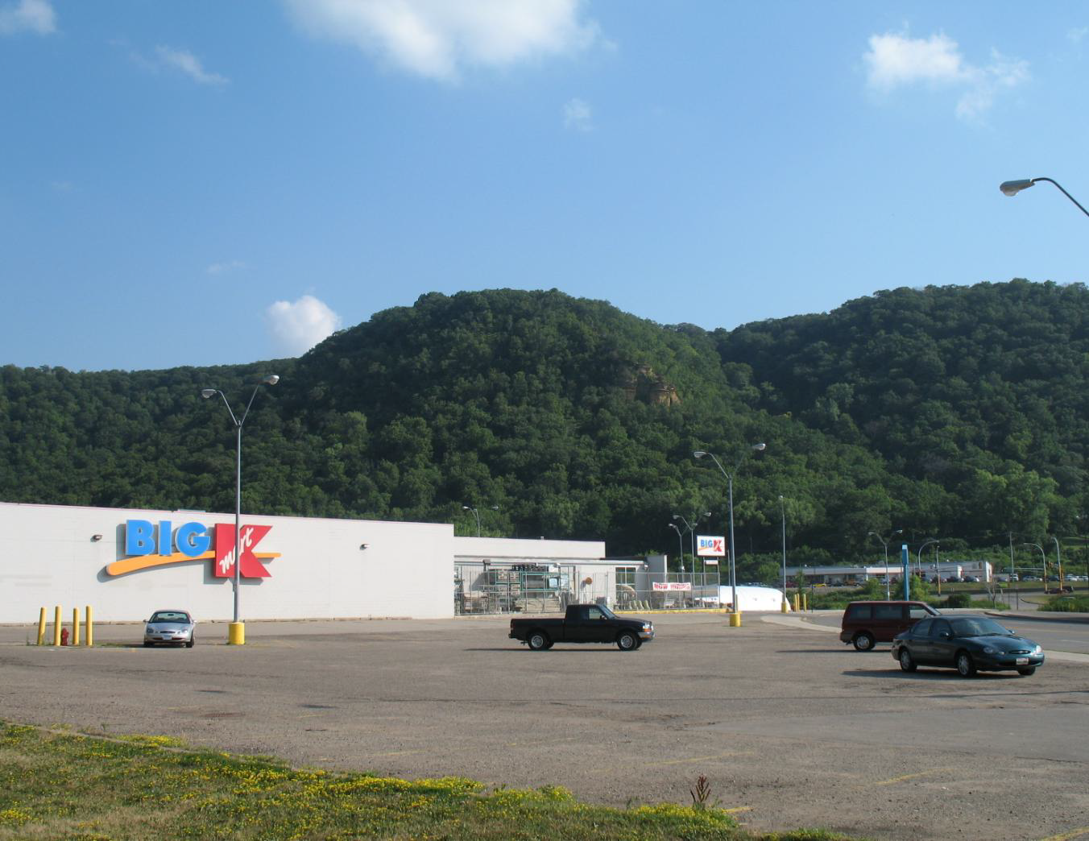
LI - Limited Industrial and Office
Areas for manufacturing, warehousing and distribution; uses that have few outside impacts, and are (or can be) located in relative proximity to non-industrial uses. Residential may be located on edges of district. | - Limit and screen any outdoor storage  - Add landscaping and materials standards, buffering from adjacent residential | 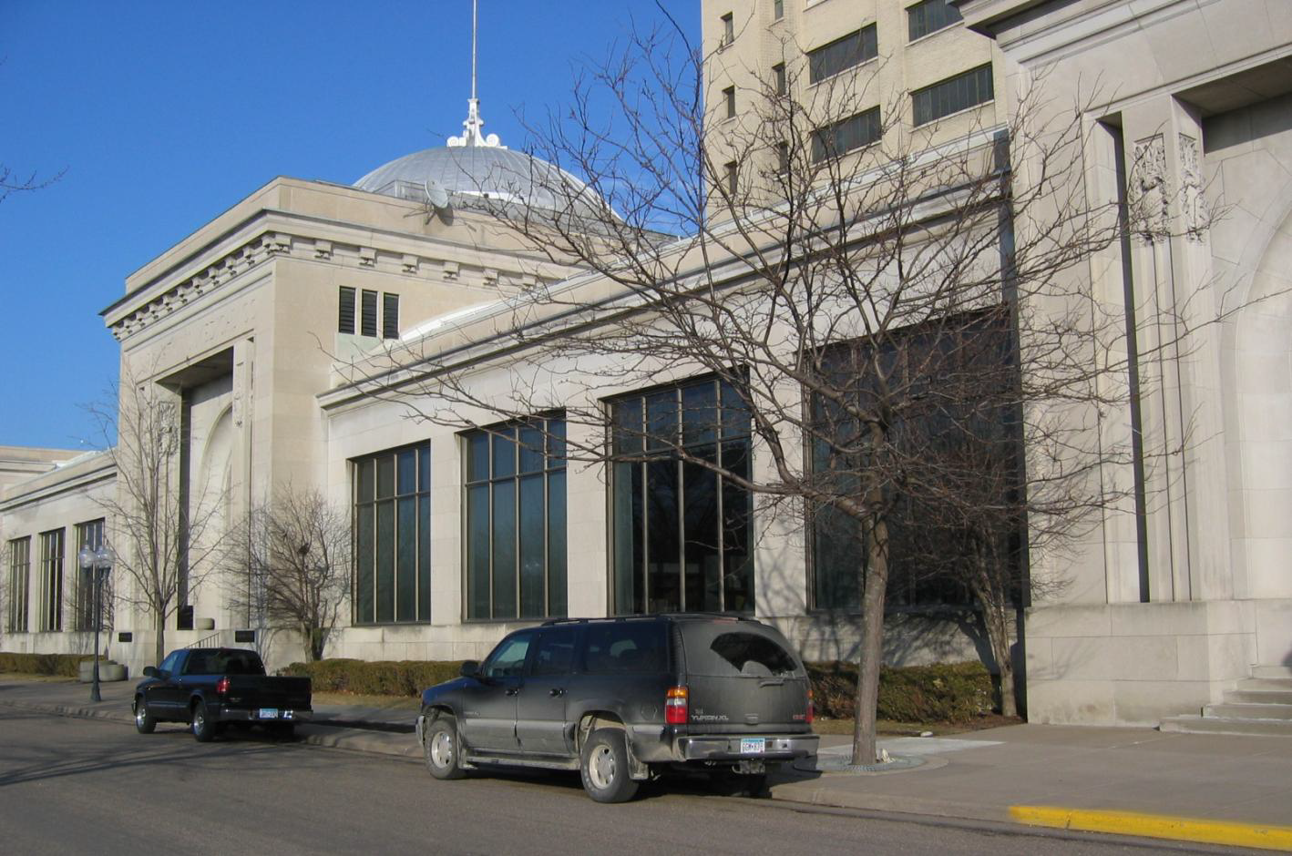 | 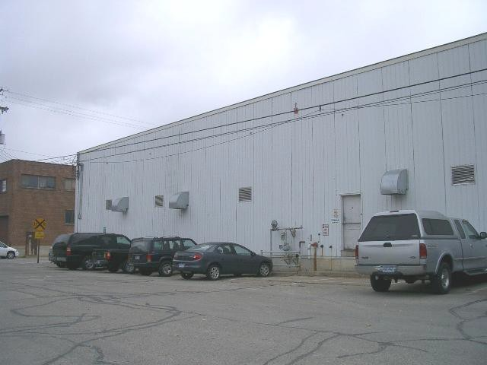

GI - General Industrial
Areas for manufacturing, processing and other activities that may have impacts off- site, and are generally isolated from other uses or buffered from them. Often contiguous to industrial riverfront, but less river-dependent. Sites should have direct access to major regional transportation facilities. | - Performance standards for environmental effects and nuisance mitigation  - Screen outdoor storage where practical | 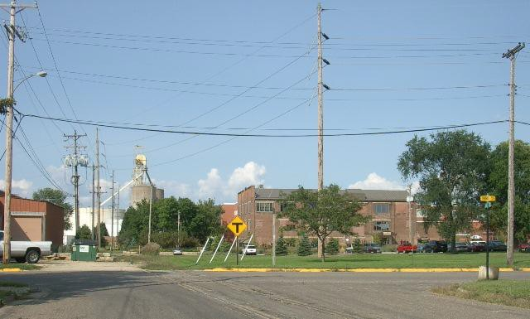 | 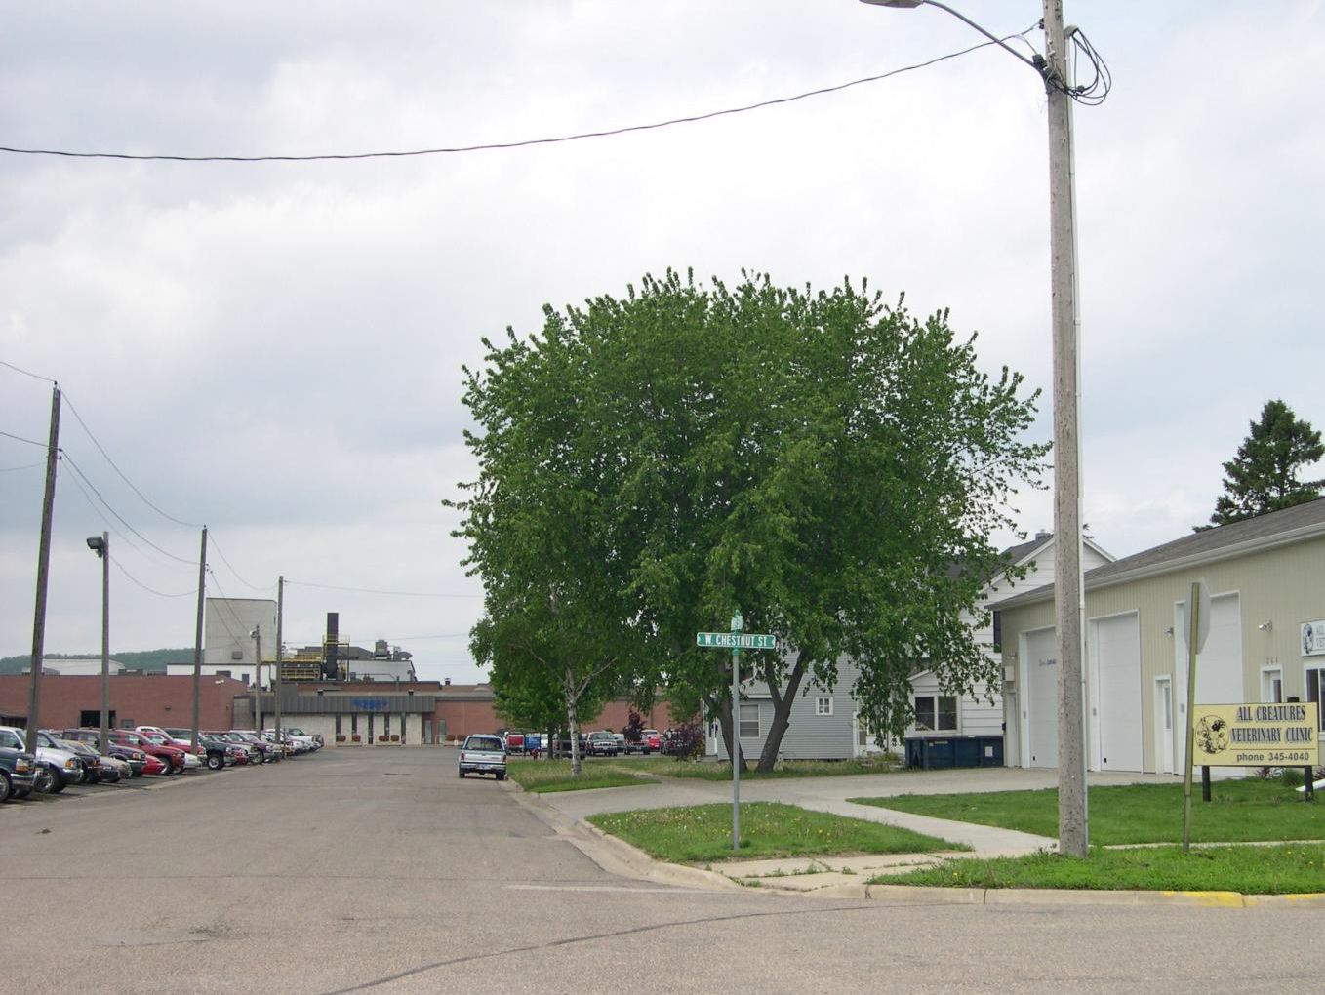

Suburban Residential
Mix of Housing styles; predominately single or two family residential dwelling units. Small scale commercial interspersed in higher traffic areas. Medium and High density residential included as part of subdivisions approvedafter adoption of this plan. Existing agricultural uses are accommodated through zoning regulations. | - May require conservation development in areas with steep slopes and other sensitive natural resources. Consider such areas for public recreation such as hiking or mountain biking trails where appropriate and potentially to meet park dedication requirements.  - Encourage small size lots and dwellings consistent with Winona’s historic development pattern to increase unit counts in new subdivisions and facilitate financial feasibility  - Incorporate connections to adjacent subdivisions without needing to return to subdivision entrance  - New subdivisions may be laid out in an interconnected grid pattern as a way of protecting open space, promote walkability, an interconnected street network, ease of navigation, and a resilient adaptive flow of movement. | 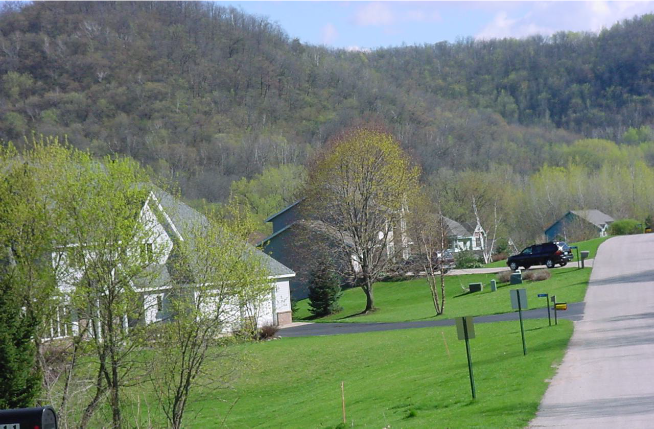 | 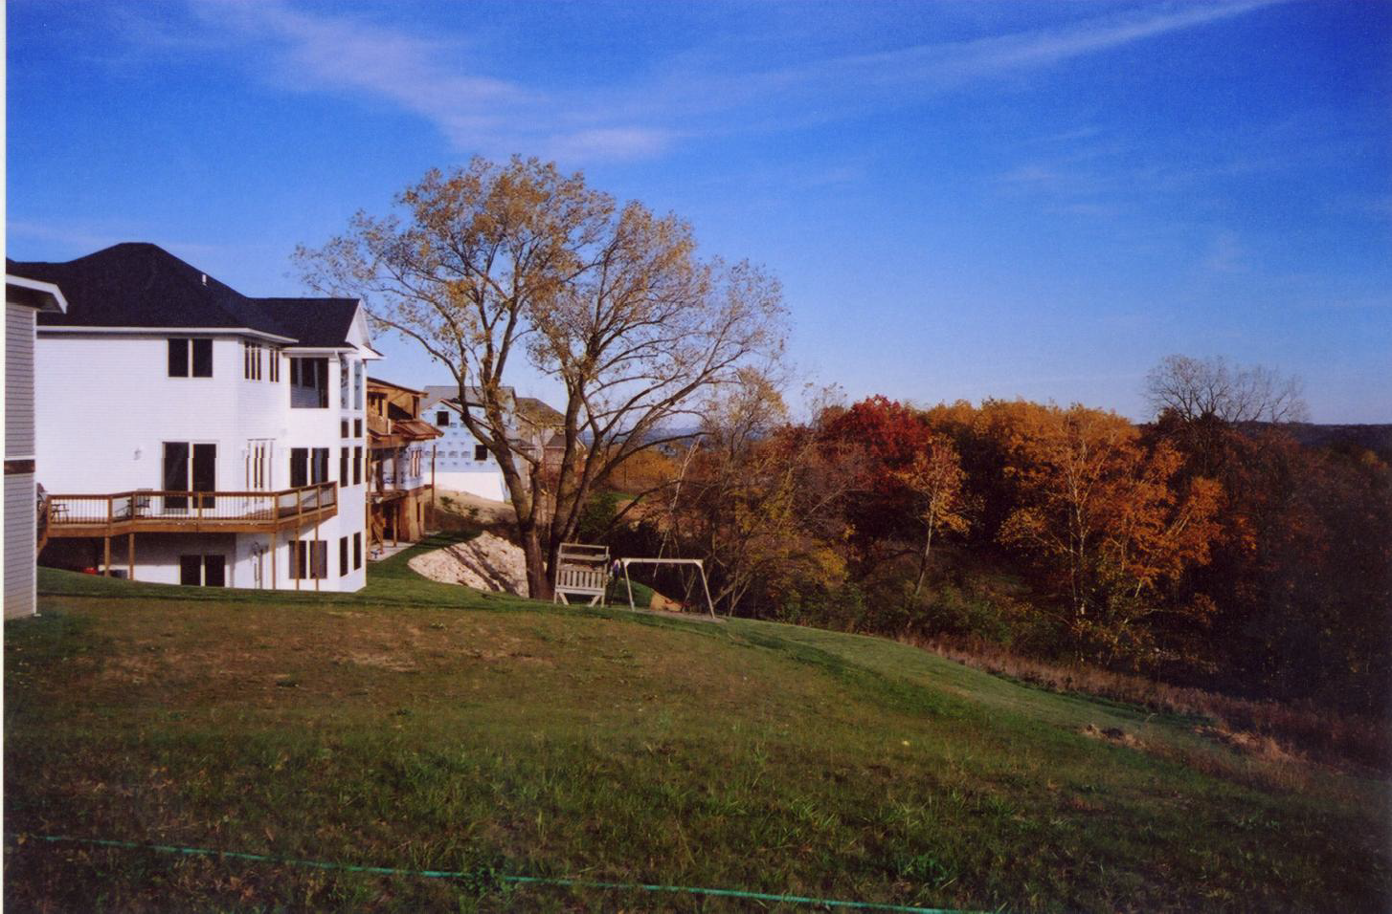
Traditional Neighborhood
Characterized by grid or connected street pattern, houses oriented with shorter dimension to the street and detached garages, some with alleys. Interspersed with neighborhood parks, schools, churches, and home- businesses; neighborhood commercial within walking distance. Includes many of City’s older neighborhoods, and a few newer ones that employ this pattern. | - Includes small-scale commercial, office, civic uses. Limitations on small-scale commercial to promote compatibility with surrounding residential uses.  - Allows for diverse housing types as transitions to more intense uses. | 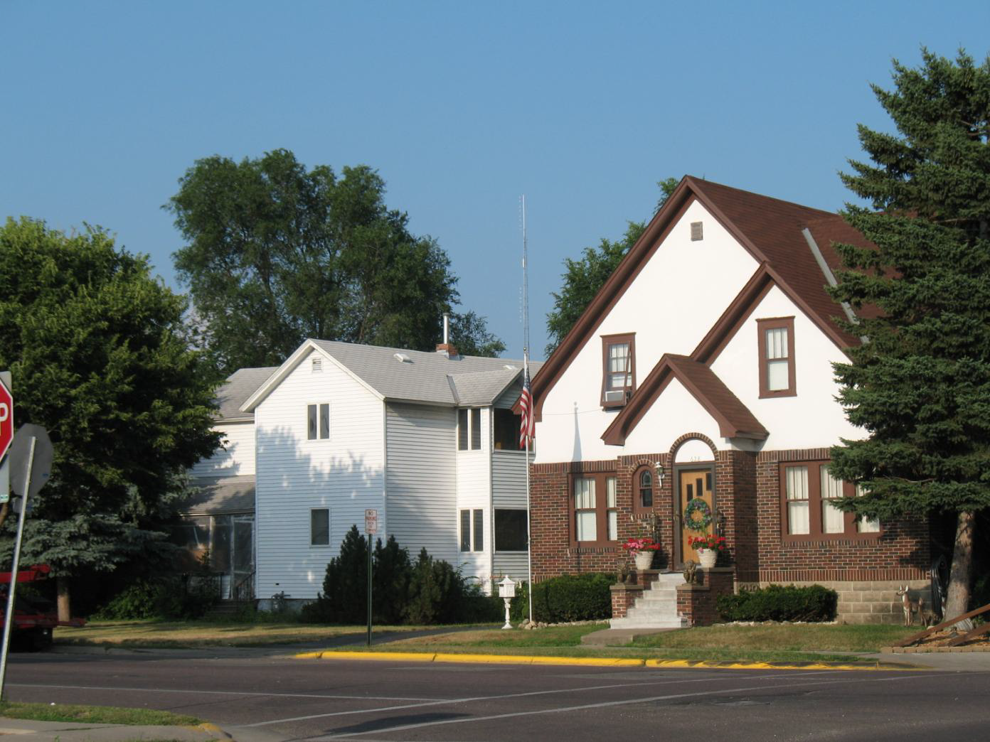 | 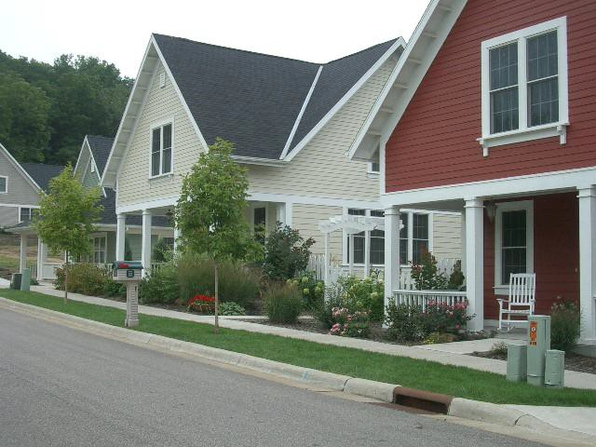
Multi-Family Residential
Potential for multi-family residential buildings, including student housing areas, live-work development, and limited retail and service. May include areas currently characterized by low to medium density residential. | - Adjacent to and/or well-connected to parks, open space, shopping, downtown, services, and transit.  - Appropriate transitions between new developments or renovated properties and adjacent dwellings. | 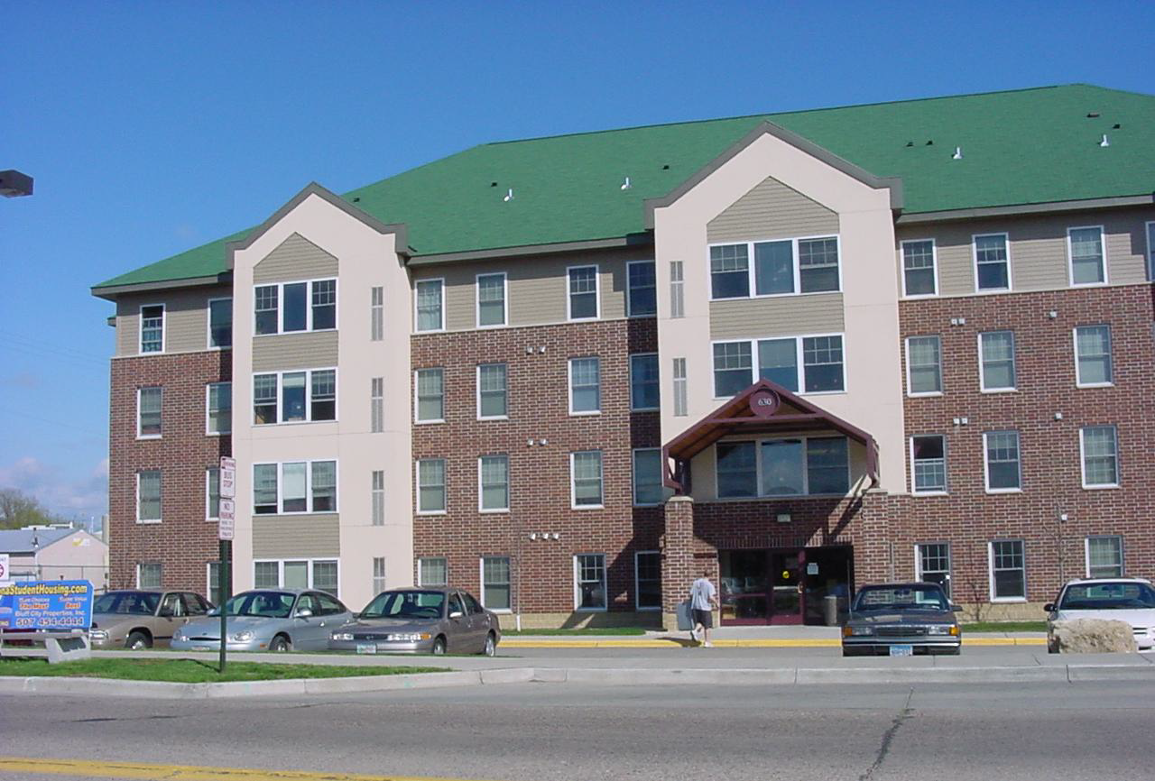 | 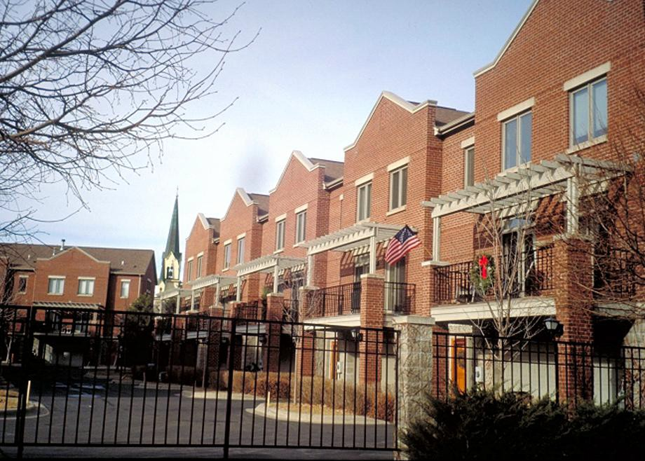

Outdoor Recreation, and Open Space
Land has high value natural resource or scenic value, or severe development limitations.  Resource types include high- value habitat, bluff, stream/ lake/river shorelands, wetlands and floodplain.  Includes public parks, golf courses and other city-owned properties such as stormwater basins.Public spaces are periodically evaluated for new, additional, and/or different uses in accordance with the needs of the public.  Designation also includes large cemeteries, the National Wildlife Refuge, and other protected lands.  Designation additionally includes marinas, Prairie Island Campground, and Boathouses (special use) | - Landscape and lighting standards  - Community access where public  - Promote multi-modal access, circulation, and use where appropriate  - Connections along linear trails and shared use paths in public rights-of-way | 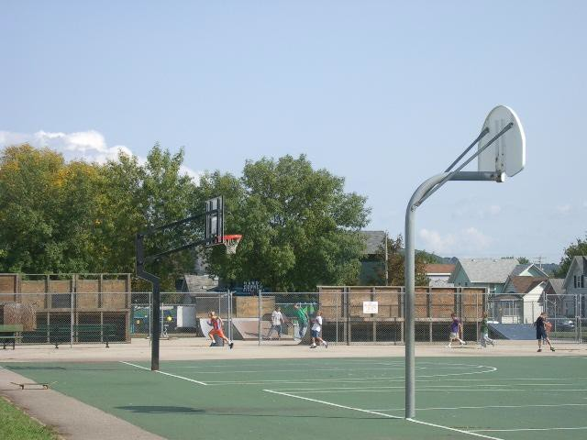  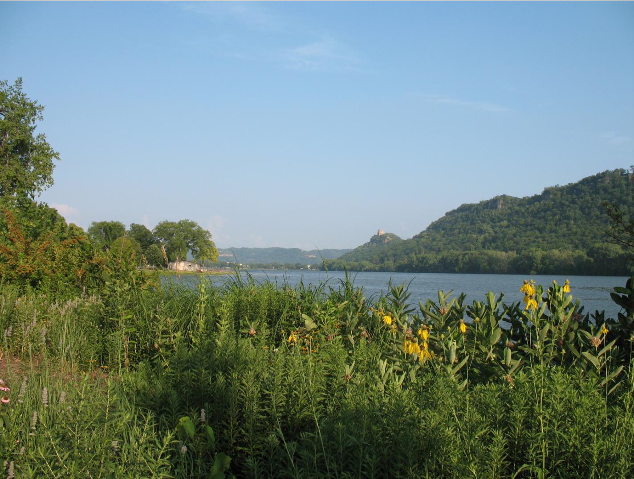 | 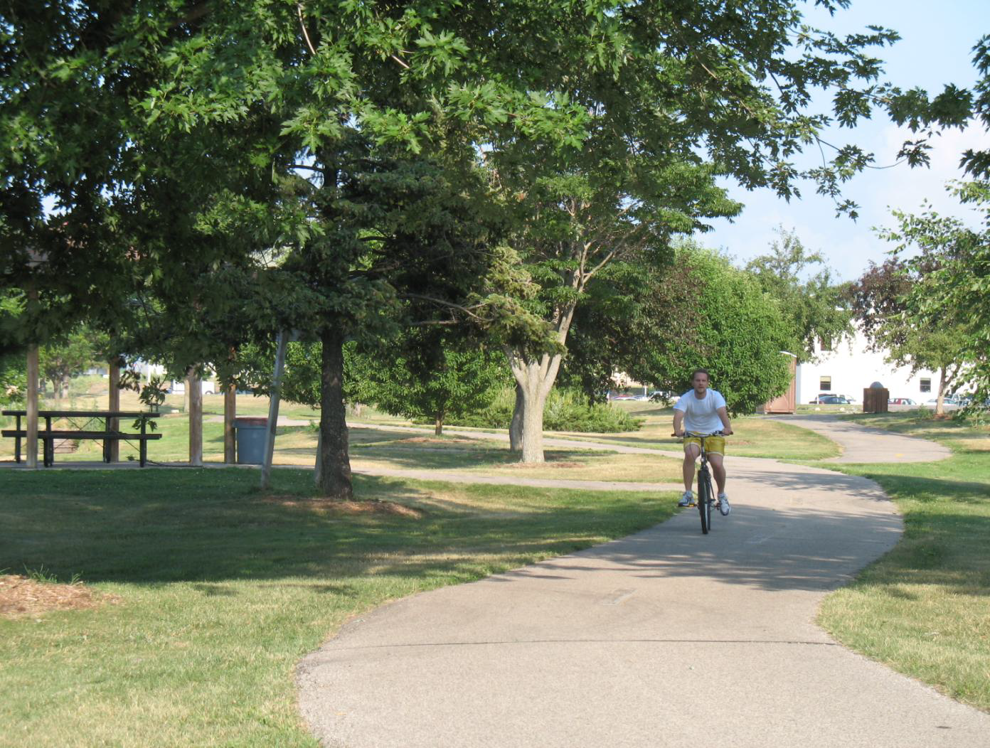  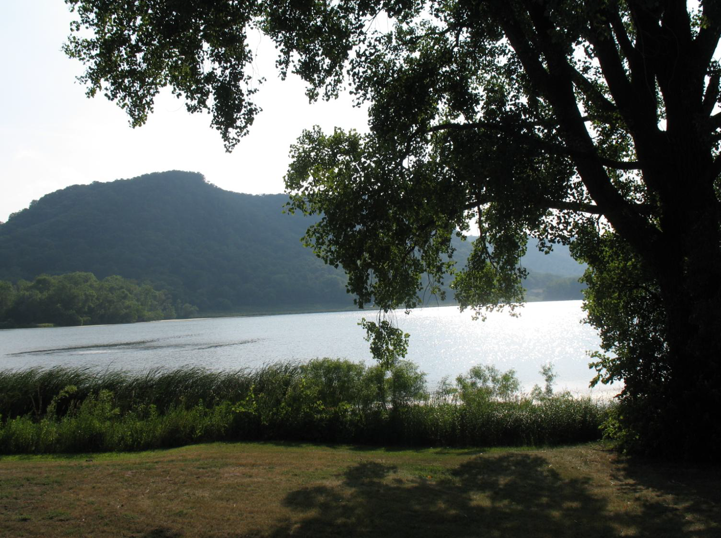

SP - Semi-Public/ Institutional
Applies to hospitals, large religious institutions, university and college and public school campuses, large religious facilities or governmental campuses, etc. | - Greater densities and heights than surrounding land use designations  - Prominent placement on lots consistent with historic development pattern in Winona  - Incorporate reduced site dimensions standards | 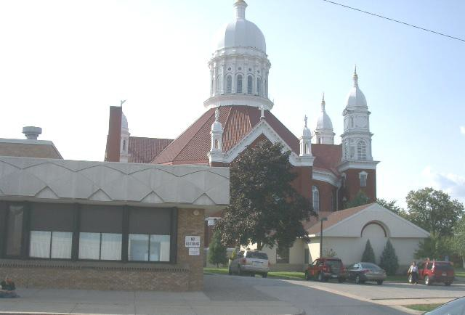 | 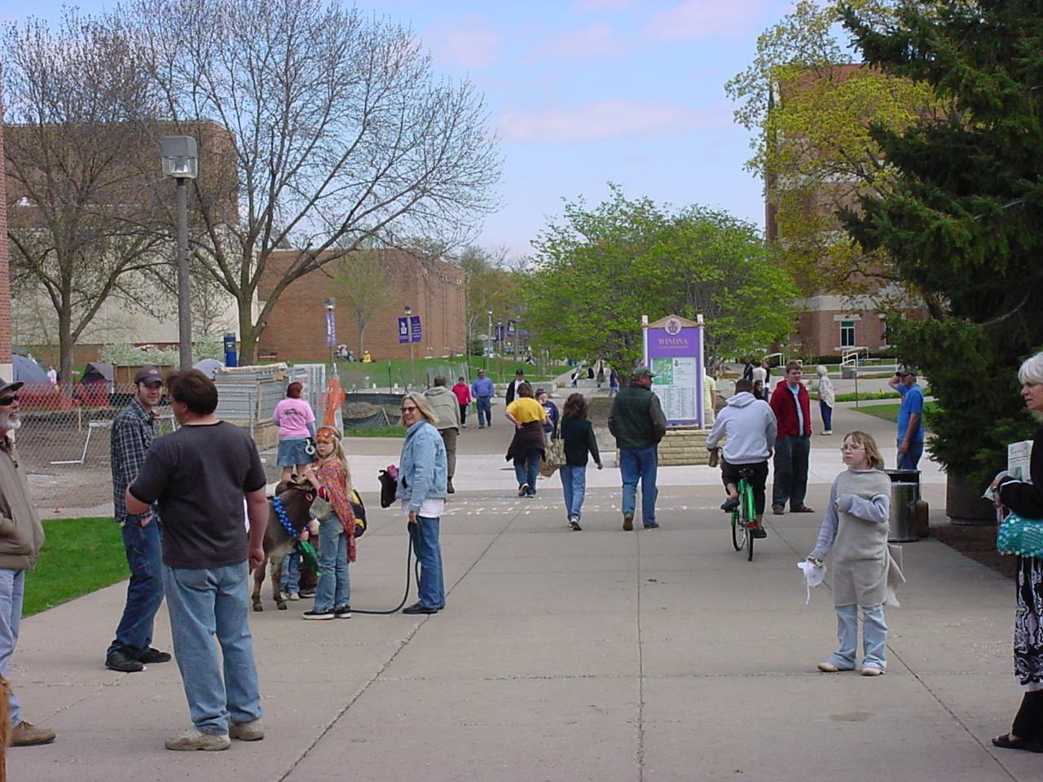
County Road 17 Suburban Residential Corridor
Includes land shown on Urban Expansion Map following County Road 17 | - Mix of residential uses for new subdivisions  - Should follow an integrated grid pattern with connected street network as allowed by topography
Hwy 43 and County Road 44 Residential, Commercial, and Limited Industrial corridor
Includes land shown on Urban Expansion Map following Hwy 43 and County Road 44 and extending to Interstate 90 | - Fiscal impact analysis appropriate prior to extending utilities into these areas.  - Significant extensions of utilities proceeded by master planning for expansion areas.  - Limited industrial uses have few outside impacts, preserve the character of the surroundings, and are (or can be) located in relative proximity to non-industrial uses.  - Should follow an integrated grid pattern with connected street network as allowed by topography

