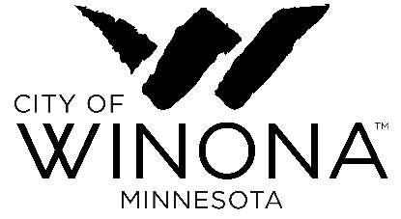
Comprehensive Plan Update: Goals and Objectives Template
Definitions
Goal – A broad general statement that describes a desired outcome
Objectives - A statement (or statements) of measurable results to help achieve a goal

Strategies - Specific actions to achieve an objective (staff to provide proposed actions for subcommittee review)
-----------------------------------------------------------------------------------------------------------------------------------------

Goal: Market Winona with a united front including collaboration with partners including the Winona Area Chamber of Commerce, Universities, Visit Winona, and City. Some of the top strengths identified by the Committee include “Quality of Life” with an emphasis on natural beauty and higher education, which topped the list of strengths of Winona for business growth. Others identified strengths include recreation, arts and culture, hardworking people, and a livable community.

Objective/s:
- Emphasize the messaging on “Quality of Life” related to natural beauty, recreation, arts, safety, etc.

- Present the message at a high level using images that promote Winona as a safe and happy place with many amenities.

Strategies: Interview company that prepared great messaging for other cities.
- Visit Winona, City, Chamber and Universities should meet to agree on the messaging and marketing plan.
- Include funding to create the messaging necessary to build population, workforce and business expansions, and start-ups.
------------------------------------------------------------------------------------------------------------------------------------------

Template
Goal: ____________________________________________
Objective/s:
- _______________________________________________________

- _______________________________________________________

- _______________________________________________________

Template
Goal: ____________________________________________
Objective/s:
- _______________________________________________________

- _______________________________________________________

- _______________________________________________________

Goal: ____________________________________________
Objective/s:
- _______________________________________________________

- _______________________________________________________

- _______________________________________________________

Goal: ____________________________________________
Objective/s:
- _______________________________________________________

- _______________________________________________________

- _______________________________________________________

Goal: ____________________________________________
Objective/s:
- _______________________________________________________

- _______________________________________________________

- _______________________________________________________

