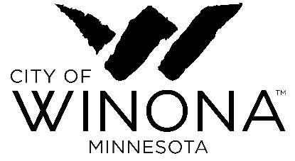
Comprehensive Plan Update: Arts and Culture Goals and Objectives
Definitions
Goal – A broad general statement that describes a desired outcome
Objectives - A statement (or statements) of measurable results to help achieve a goal

Strategies - Specific actions to achieve an objective (staff to provide proposed actions for subcommittee review)
-----------------------------------------------------------------------------------------------------------------------------------------
Goal: Enhance City support systems for Winona’s creative life
Objective/s:
- Refocus the City’s leadership role from direct programming to service, support, and leadership of the community’s efforts.
- Rebuild the Fine Arts Commission as the Creative Winona Commission with updated mission, qualifications, role and membership.
- Establish an inaugural citywide Public Art Program.
- Develop a long-term public art master plan.
- Create an equitable, transparent arts grants program open to all Winona nonprofit arts and cultural organizations and artists.
- Expand the Creative Laureate program to have one or more artists work within City departments on collaborative projects.
- Refocus the City Arts Office as the Office of Arts, Culture and Creative Economy
- Provide staff support for implementation of the Arts & Culture plan.
Goal: Promote and grow Winona’s creative economy
Objective/s:
- Increase Winona’s capacity to attract and retain creative talent.
- Develop an arts and culture strategy to position Winona to attract all age groups, from college students through to retirees, to Winona.
- Support growth in Winona’s culinary sector.
- Continue to promote arts and culture as an important asset for Winona
- Expand arts education and lifelong learning opportunities
- Provide accountability in implementation of the Arts & Culture plan

Goal: Support inclusive creativity for all residents and visitors
Objective/s:
- Invite the creative community to develop inclusive new activities for all Winonans.
- Develop year-round arts and cultural programming
- Develop a communitywide cultural equity and inclusion initiative
- Incentivize cross-over activities for creative and outdoor recreation

Goal: Expand access to creative sector facilities and spaces
Objective/s:
- Complete the former Masonic Temple project as a multidisciplinary performing and visual arts center.
- Inventory and make available existing public spaces for creative activities.
- Develop live/work spaces for artists and creative, including mixed use projects.
- Develop a Creative Space Program to incentivize new facilities, spaces, and places

